2020
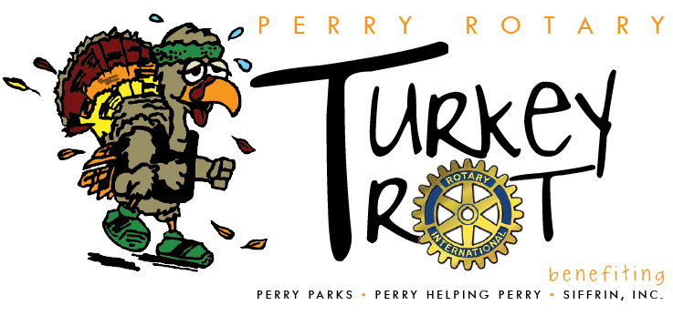
Meyers Lake YMCA * Perry Helping Perry

EVENT SPONSORS $1,000
- Large Company Logo on the event T-Shirt , given to each participant
- Company Banner at the event
- Recognized on all event promotional materials and advertising
- Recognized on the Perry Rotary website for 1 year
- 2 Complimentary Run/Walk Participants
- Table at the event to display company information, optional
- Provide promotional materials to be given to each participant, optional
T-SHIRT SPONSORS $500
- Company logo listed on the back of the event T-shirt, given to each participant (more than 3,000 people)
- Recognized on the Perry Rotary website for 1 year
- 1 Complimentary Run/Walk Participant
- Provide promotional materials to be given to each participant, optional
QUARTER-MILE MARKER SPONSORS $250
- Company name on a ¼ mile marker placed along the race route
- Provide promotional materials to be given to each participant, optional
----------------------------------------------------------
Deadline: October 15, 2020
Company or Individual Name (as it appears on signage): _________________________________________
Contact: _________________________________________ Phone: _____________________________
Email: _______________________________________________________________________________
I want to be a(n):
____ Event Sponsor ____ T-Shirt Sponsor ____ ¼ Mile Marker Sponsor
Please make checks payable to: Perry Twp Rotary, and mail to: TURKEY TROT, PO Box 80371, Canton, OH 44708

